**AREVALO, DIANE ABBY**

**BSIT-II**

**FUNDAMENTALS OF DATABASES – WEEK 3 – ACTIVITY 3**

Supply/perform what is asking in the following statements. Attach or put a screenshot for each number to support your answers.

1. Assuming that you are creating a database table design, provide at least 10 attributes that corresponds to the information of the following:

a. Student (E.g. Stud_ID, Stud_No)

- Student_FName - Birth_Date

- Student_M Name - Phone_Number

- Student_LName - Email_Address

- Student_Address - Course_Name

- Student_Age - Course_Year

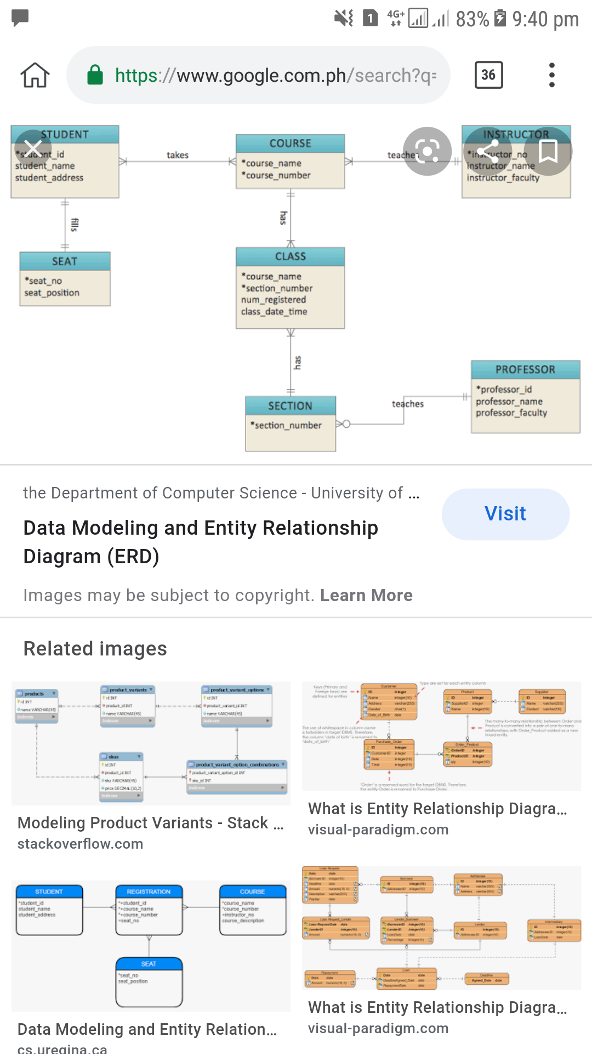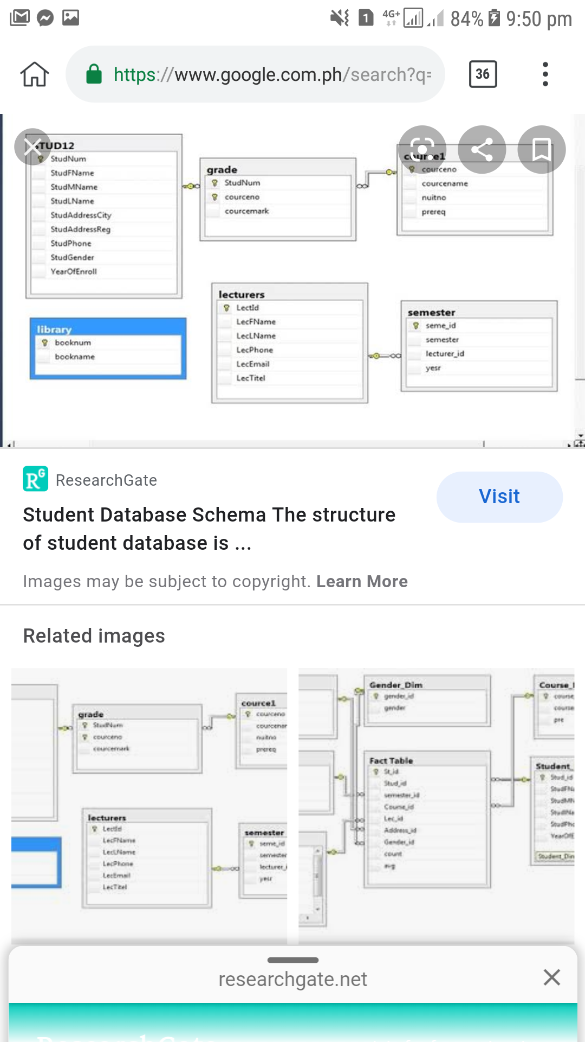

b. Employee (E.g. Emp_ID, Emp_No)

- Employee_FName - Employee_Address

- Employee_LName - Phone_Number

- Birth_Date - Hire_Date

- Sex - Job_Title

- Email_Address - Salary

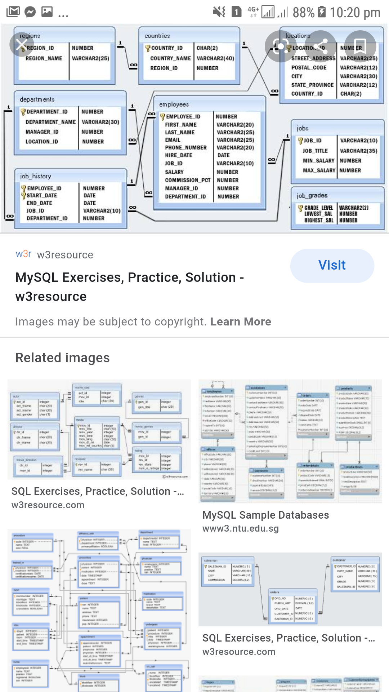

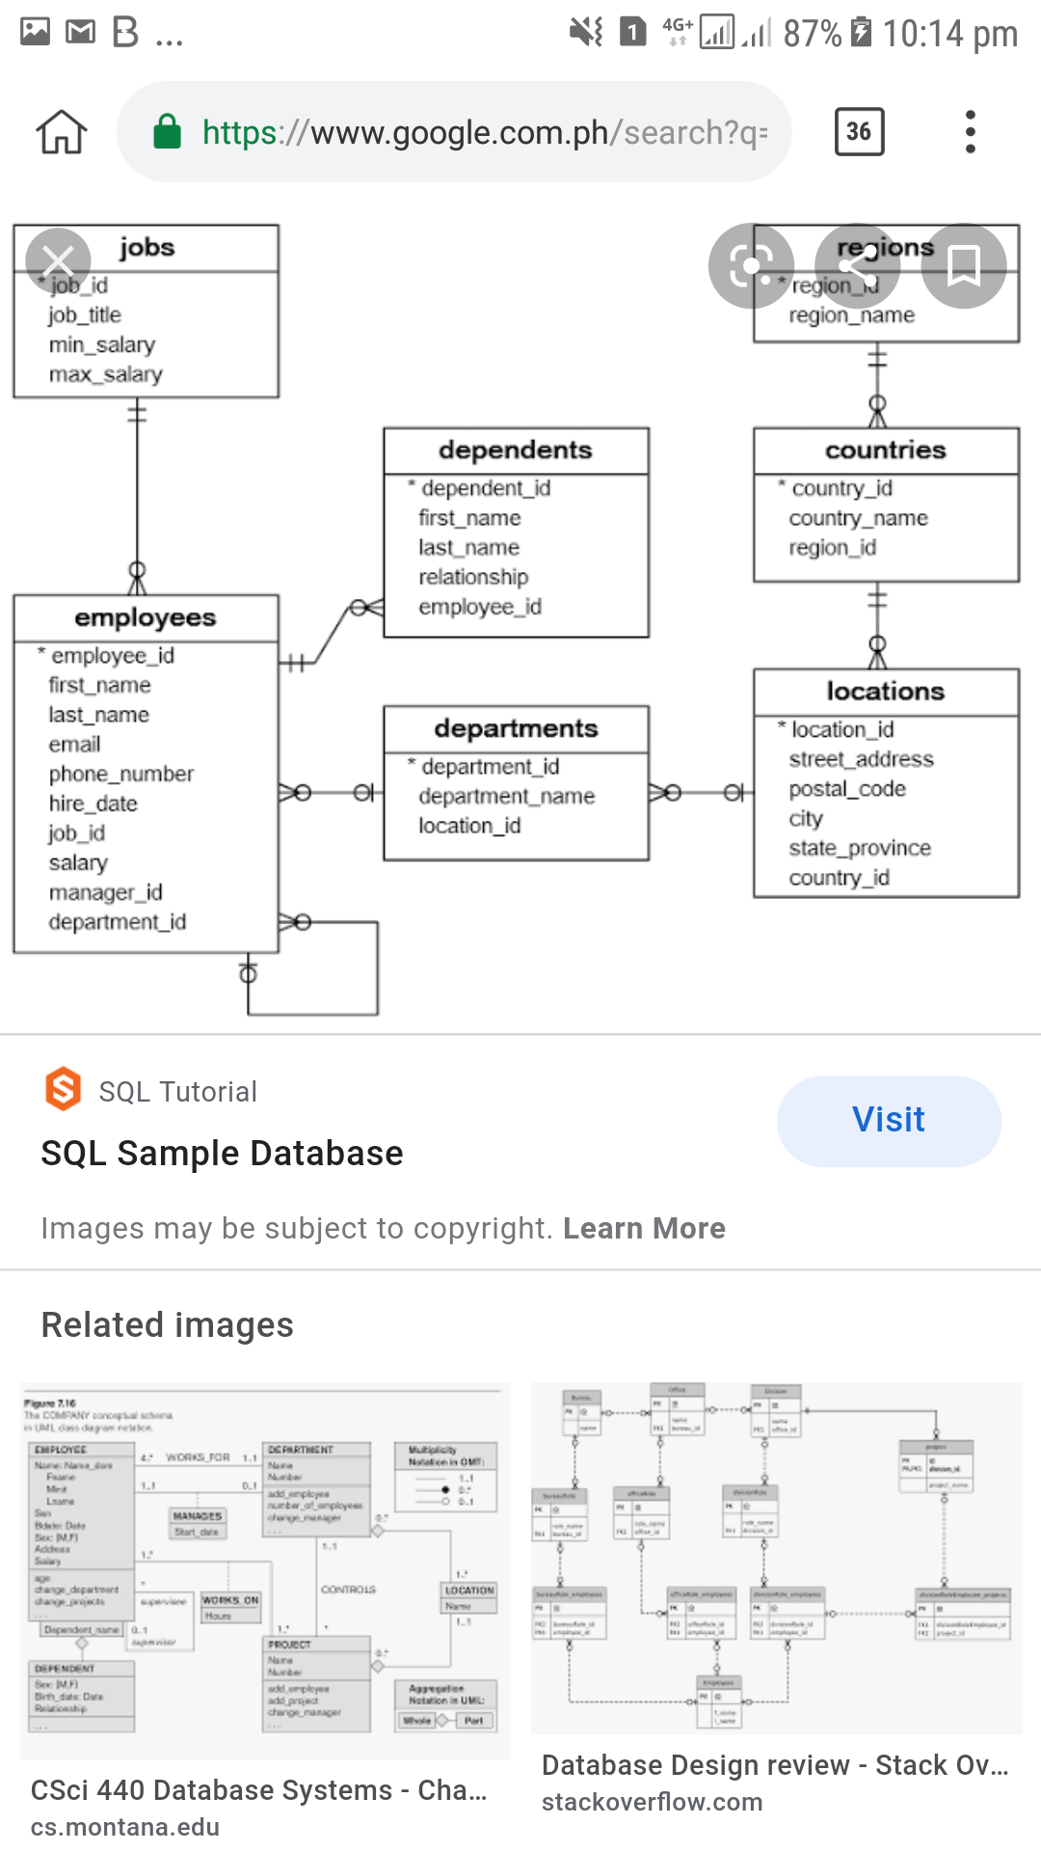

2. For each table name field or attributes, think and give the preferred data types for each and lengths (no. of expected number of characters).

Example:

Student Table

Attributes Datatype Length

Stud_ID int 5

Stud_FName text 25

**Student Table**

Attributes Datatype Length

Student_FName text 7

Student_MName text 5

Student_LName text 10

Student_Address varchar 25

Student_Age int 2

Birth_Date timestamp 12

Phone_Number int 12

Email_Address varchar 20

Course_Name text 30

Course_Year int 10

**Employee Table**

Attributes Data Type Length

Employee_FName text 8

Employee_LName text 13

Birth_Date timestamps 10

Sex text 6

Email_Address varchar 17

Employee_Address varchar 24

Phone_Number int 12

Hire_Date timestamps 10

Job_Title text 15

Salary int 5